[Lab] Getting started, Netlab

# Summary:

In this lab you will connect up and explore the lab environment we will be using for the remainder of the semester. Your work pod is “persistent”, meaning that the work you do in each class will be available the next time you log into your lab environment. You can access the lab environment 24/7 from anywhere that has decent internet connectivity.

|  |
| --- |
| Summary:  Video Walkthrough of lab set up:  First we will set up your lab pod:  Step 1) Change Password:  Step 2) Set email address:  Step 3) Set Date and Time Settings:  Next we will start up your pod:  Step 1) First we need to schedule a lab:  Step 2) Select a lab start time:  Step 3) Confirm your reservation:  Step 4) You can now enter the lab environment:  Log into your lab virtual machine:  Step 1) Click anywhere in the laptop screen:  Step 2) You are now at your command prompt:  ToDo:  Paste your screenshot here:!!! |

# Video Walkthrough of lab set up:

<https://youtu.be/a7iNx7v855M>

# First we will set up your lab pod:

**URL:** https://netlab2.madisoncollege.edu

**UserName:** <For the username, use you BlackBoard username>

**PassWord:** **Python123**

|  |
| --- |
|  |

## Step 1) Change Password:

You will need to change the initial password from the default to something that you select.

|  |
| --- |
|  |

## Step 2) Set email address:

You can add an email address if you want to. We don’t use it for this particular class as we use BlackBoard.

|  |
| --- |
|  |

## Step 3) Set Date and Time Settings:

Set up to use Central Time and Time Display Format to 12 hours.

|  |
| --- |
|  |

# Next we will start up your pod:

The next step is to start up a lab pod.

## Step 1) First we need to schedule a lab:

We make a pod reservation and do all of our lab work in a cloud based VIrtual Machine.

Note: The reason reservations are required is to allow netlabs to release resources when they are not being used.

|  |
| --- |
|  |

## 

## Step 2) Select a lab start time:

This sets the time that your lab will start up. For our purposes we will almost always want the pod to start up immediately. Note: By default the “Length of Reservation” should be 7hrs,34min.

|  |
| --- |
|  |

## 

## Step 3) Confirm your reservation:

|  |
| --- |
|  |

## Step 4) You can now enter the lab environment:

|  |
| --- |
|  |

# 

# Log into your lab virtual machine:

## Step 1) Click anywhere in the laptop screen:

|  |
| --- |
|  |

Step 2) Login

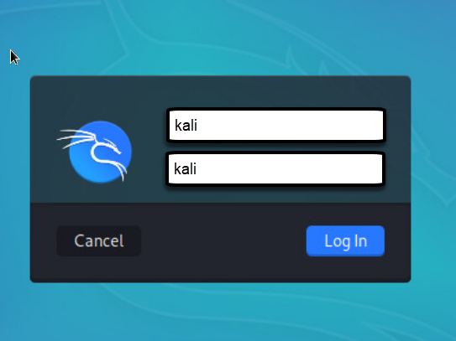

## Step 3) Open a Bash shell:

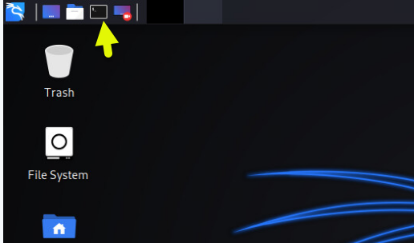

## 

## Step 2) You are now at your command prompt:

|  |
| --- |
|  |

# ToDo:

1. Once connected, use the “echo” command as in the video print your full name out to the screen.
2. Take a screencap showing your name printed out on the screen..

Example output:

|  |
| --- |
|  |

# A1 [Screenshot]: Take a screencap showing your name printed out on the screen